**IDEA**

**week1**

Game Types & Style

**1.1 CYX**

**Type: Tower Defense Game**

Features:

1. Selectable difficulty (directly adjusted through monster movement speed and health values).
2. High degree of visual customization (scenes, monsters, defense towers).
3. Rich visual effects (enemy movement trails, tower attack effects, etc.).
4. Upgrade trees and combo skills to increase replayability and player depth.
5. https://www.bilibili.com/video/BV1kQMGzyErb/?spm_id_from=333.1007.top_right_bar_window_history.content.click&vd_source=ac06e7bff2b67fce46a367296c55e9a8
6. https://www.bilibili.com/video/BV1xG4y117xJ/?spm_id_from=333.337.search-card.all.click

**1.2 Controllable Object Type (Shooting games, Snake-style games, etc.)**

**Features:**

1. Stronger interaction because the player controls a specific entity.
2. The entire game revolves around the player character, making the narrative clearer.
3. Requires fewer additional texture assets; easier to produce and visually cleaner.

：

1. https://www.bilibili.com/video/BV1ng4y187kj/?spm_id_from=333.337.search-card.all.click&vd_source=ac06e7bff2b67fce46a367296c55e9a8
2. https://www.bilibili.com/video/BV1eMXKYjE1X?spm_id_from=333.788.videopod.sections&vd_source=ac06e7bff2b67fce46a367296c55e9a8
3. https://www.bilibili.com/video/BV1HBL4zKEgF/?spm_id_from=333.337.search-card.all.click&vd_source=ac06e7bff2b67fce46a367296c55e9a8
4. https://www.bilibili.com/video/BV1Mt411x7qK/?spm_id_from=333.337.search-card.all.click&vd_source=ac06e7bff2b67fce46a367296c55e9a8
5. https://www.bilibili.com/video/BV1Sa411E7By?spm_id_from=333.788.videopod.sections&vd_source=ac06e7bff2b67fce46a367296c55e9a8

**2 ly**

**2.1Rhythm Game**

This genre hasn’t been explored much in our group before.

Not limited to “Piano Tiles”-style gameplay.  
Example idea: The character walks forward, follows drum beats, attacks enemies rhythmically.  
Can be combined with cultural themes.

|  |  |
| --- | --- |
| image1.png | image2.png |

https://www.xiaohongshu.com/discovery/item/687287820000000010027c73?source=webshare&xhsshare=pc_web&xsec_token=ABoIuFUVMiY_RwjyHP1EaD8YEySq7QhMBiCtwSoTrO2zM=&xsec_source=pc_share

* **ore Implementation Points**
* **(1) Timing System + Judgement (Core of Rhythm Games)**
* Use performance.now() for high-precision timing.
* Use audio playback time (WebAudio API) as the master clock to avoid frame-rate drift.
* Implement judgement windows (Perfect / Great / Good / Miss) based on millisecond thresholds.
* **(2) Beatmap System**
* Store each note in JSON/CSV format:
* time (ms)
* lane
* type (tap / hold / slide)
* duration
* In the game loop:
* Advance notes from “not yet appeared” → “judgable” → “missed” based on current time.
* **(3) Input & Feedback**
* Map keyboard/mouse/touch input to lanes.
* Implement:
* Combo system
* Score calculation
* Health bar
* Judgement text
* Screen shake (camera shake)
* **Visual Style Ideas**
* Geometry-based (points & lines).
* Strong impact effects.
* Beat-driven visual emphasis.
* Example concept:  
  Burn and recolor photos following the rhythm; lighter click duration defines beat length.

|  |  |
| --- | --- |
| image3.png | image4.png |

https://www.xiaohongshu.com/discovery/item/691c63f9000000001d03f429?source=webshare&xhsshare=pc_web&xsec_token=ABFfyjKlqMy1CJRjGnel5HBjZndHjeX8g-TIEBNP29LtM=&xsec_source=pc_share

|  |  |  |
| --- | --- | --- |
| image5.png | image6.png | image7.png |

gemini

https://www.xiaohongshu.com/discovery/item/69241ab6000000001e036ed3?source=webshare&xhsshare=pc_web&xsec_token=ABn3P9M2DIUE9aw4O95T6tTx1qqBWADu4qo56Le32z1mM=&xsec_source=pc_share

|  |  |  |
| --- | --- | --- |
| image8.png | image9.png | image10.png |

|  |  |
| --- | --- |
| image11.png | image12.png |

|  |  |
| --- | --- |
| image13.png | image14.png |

|  |  |
| --- | --- |
| image15.png | image16.png |

https://www.xiaohongshu.com/discovery/item/67f6a093000000001d0386af?source=webshare&xhsshare=pc_web&xsec_token=ABeP1moIIm4BuqPqzjUI2CUEk6N7JIYAFAfBuTdbdW1to=&xsec_source=pc_share

**2.2 Arcade Games**

Reference multi-level games:

* Super Mario
* Fireboy and Watergirl
* Ski Adventure

Levels can be redesigned stylistically while preserving mechanics.

|  |  |  |  |
| --- | --- | --- | --- |
| image17.jpeg | image18.jpeg | image19.jpeg | image20.jpeg |

http://xhslink.com/o/76TOjZDoFsy

**2.3 Tower Defense**

|  |  |
| --- | --- |
| image21.png | image22.png |

**2.4 Tile Matching Game**

|  |  |  |
| --- | --- | --- |
| image23.png | image24.png | image25.png |

**2.5 Push Box Game**

17 【记录第一个自己完成的游戏 - LyFin | 小红书 - 你的生活兴趣社区】 😆 cQ4AJ2kEo5UdrwE 😆 https://www.xiaohongshu.com/discovery/item/6953a329000000001e0307d0?source=webshare&xhsshare=pc_web&xsec_token=AByIqKM3vdf23SKcAdwQ1dyss_i5Ok58EnlC-pyq1QSpg=&xsec_source=pc_share

**3 lch**

|  |  |
| --- | --- |
| image26.png | image27.png |

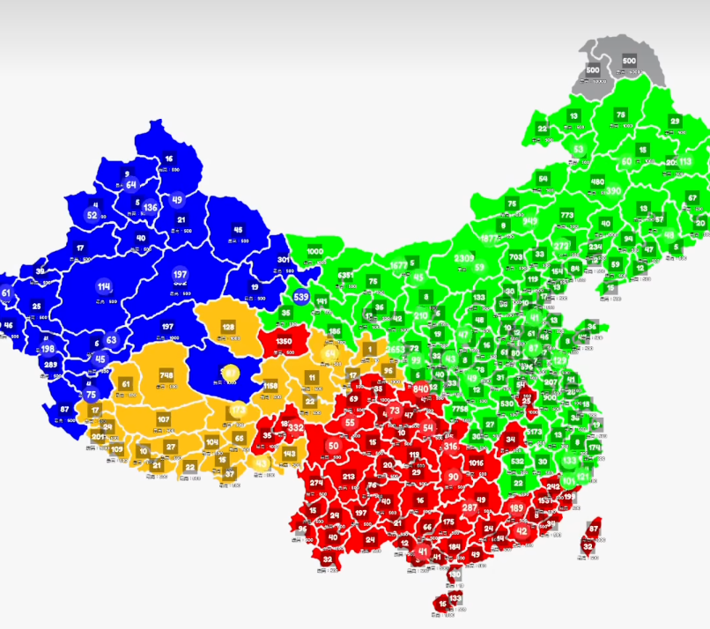

https://www.bilibili.com/video/BV1ZeikYjEPS?spm_id_from=333.788.videopod.sections&vd_source=c5f651a7f8ad9f34fd91e0ba736f9979

https://www.bilibili.com/video/BV12P4y1s71J?spm_id_from=333.788.recommend_more_video.1&trackid=web_related_0.router-related-2206146-6qf4g.1769272658477.549&vd_source=c5f651a7f8ad9f34fd91e0ba736f9979

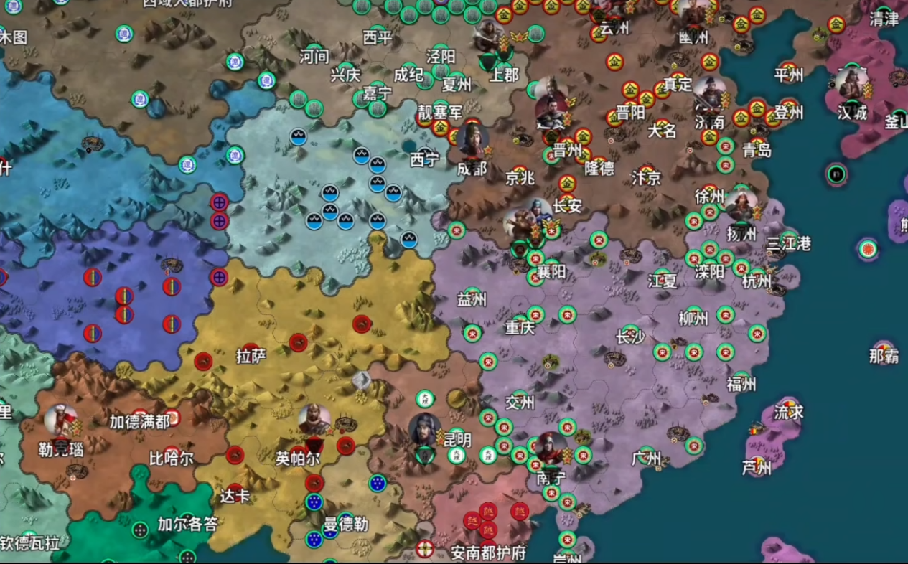

**I. Game Positioning & Core Experience**

**1. Game Type**

**Node-conquest + Push-line Strategy Game**

* **Not high-APM real-time control.**
* **Focused on rhythm and frontline management.**
* **Suitable for:**
  + **Single-player campaign**
  + **Multiplayer battles**

**2. Core Experience Goal**

**Players do NOT win by clicking fast.**

**They win by:**

* **Frontline advancement**
* **Multi-wave attacks**
* **Defensive counter-push**
* **Resource allocation**

**One-sentence summary:  
A strategy game centered around whether the frontline can hold.**

**II. Map & Node System**

**1. Nature of the Map**

* **The map is only visual and historical context.**
* **Real gameplay occurs on a node network (Graph).**
* **Nodes have fixed connections (only adjacent nodes can send troops).**

**2. Node Definition**

**Each node represents:**

* **A city**
* **Warzone**
* **Fortress**
* **Industrial area**

**Each node has:**

* **Faction ownership**
* **Troop count**
* **Fortification state**
* **Production and defense capability**

**III. The Three Core Parameters (The Iron Triangle)**

**Every city must balance these three:**

**1. Defense Coefficient**

* **Determines how hard the city is to capture.**
* **Affects damage calculation.**
* **Influenced by city type and fortification.**

**2. Production Rate**

* **Troop growth per second.**
* **Economic base of offense and defense.**

**3. Capacity**

* **Maximum theoretical troop capacity.**
* **Determines if the city functions as a frontline or backline fortress.**

**Relationship:**

* **Defense → Resistance**
* **Production → Sustained pressure**
* **Capacity → Frontline thickness**

**IV. Max Garrison**

**Concept Distinction**

* **Capacity: long-term static limit**
* **MaxGarrison: short-term dynamic stable limit**

**Formula**

**MaxGarrison = Capacity × g**

**Recommended g values:**

* **Normal city: 0.75–0.90**
* **Industrial city: 0.60–0.80**
* **Fortress: 0.90–1.00**

**Newly Captured Penalty**

**After capture:**

* **MaxGarrison = 40%–60%**
* **Recover over 10–20 seconds**

**Effect:**

* **Newly captured cities are fragile.**
* **Natural formation of frontlines.**

**V. WWII Europe Node Design Logic**

**Why WWII Europe works well:**

1. **Highly concentrated industrial centers**
2. **Clear defensive bottlenecks**
3. **Historically clear push paths**

**Avoid:  
❌ Country = one node**

**Correct:  
✅ Country = region collection  
Region = node**

**Recommended total nodes:  
25–40 (ideal for 4–8 players)**

**VI. Warring States Map (China)**

**Period: Late Warring States  
Nodes: Feudal states / Core cities**

**Features:**

* **Strong push-line feeling**
* **Clear defensive chokepoints**
* **Natural hierarchical structure**

**VII. Fortification System**

**F ∈ [0,1]**

**Initial:**

* **Neutral: 0.6**
* **Normal city: 0.8**
* **Core fortress: 1.0**

**Defense formula:  
Defense = 1 + D × F (D ≈ 0.2–0.4)**

**Damage reduction on first hit:  
FirstHitFactor = 1 − R × F (R ≈ 0.15–0.3)**

**Damage reduces F by 0.10–0.18  
Repair when not attacked: +0.02–0.05/s  
Requires stationed troops to repair.**

**After capture:  
F resets to 0.30–0.50**

**VIII. Siege & Casualty System**

**Principles:**

* **Surface: 1:1 casualty intuition**
* **Underlying: Defense + Fortification modifiers**

**Damage model (conceptual):**

* **damage = sent**
* **if firstHit:**
* **damage *= FirstHitFactor**
* **damage /= Defense**
* **defender.troops -= damage**
* **F -= Δ**

**Capture condition:  
If defender.troops ≤ 0 → city changes ownership**

**IX. Troop Movement System**

* **Discrete send command**
* **Cooldown: 0.6–1.0s**
* **Travel time (adjacent): 0.9–1.6s**
* **Distance-normalized**

**Purpose:**

* **Create attack wave rhythm**
* **Enable strategic pacing**

**X. Difficulty Design**

**Normal**

* **Easier fortification break**
* **Faster repair**
* **Faster post-capture recovery**
* **Conservative AI**

**Hard**

* **Harder fortification break**
* **Slower repair**
* **More fragile newly captured cities**
* **Aggressive AI**

**Multiplayer Modes (From Easiest to Hardest)**

**A. 4–8 Player Node Conquest (Recommended First Version)**

* **Each player starts with 1–2 nodes.**
* **Win by:**
  + **Percentage control**
  + **Last survival**
  + **Score**

**B. Team Mode (2v2 / 3v3)**

* **Shared victory condition**
* **Troop support between teammates**
* **Requires snowball balance**

**C. Large Room (8–20 Players)**

**Not recommended initially.**

**Requires:**

* **Strong caps**
* **Supply lines**
* **Decay systems**

**Multiplayer Synchronization**

**Best approach:  
Server-authoritative + command-based sync.**

**Client sends:**

* **SEND_TROOPS**
* **UPGRADE**
* **EMOTE/CHAT**

**Server handles:**

* **Validation**
* **Production tick**
* **Combat**
* **Occupation**
* **Fortification changes**

**Stable even with 150–300ms latency.**

**Multiplayer Balance Mechanisms**

1. **Stronger cap limits**
2. **Supply line system (disconnected nodes produce less)**
3. **Anti-focus-fire mechanism (damage diminishing returns)**
4. **Post-capture vulnerability period**

**Multiplayer Victory Conditions**

**Recommended:**

1. **Score-based (best)**
2. **Last survivor**
3. **Key-point capture (hold for 30s)**

**Week 2 – Technical Challenges**

* **Rhythm game**
* **Tower defense**
* **Strategy game**
* **p5.js implementation**